A PROJECT REPORT

ON

“Liquid Battery Cooling System”

By

Mr. Anshul Wankhede Mr. Audumbar Awate Mr. Anirudh Shelar Mr. Preston Trinidade

Guide

Prof. Rahul D. Pharande



Department of Automobile Engineering

Dr. D. Y. Patil Educational Academy's

D. Y. PATIL SCHOOL OF ENGINEERING ACADEMY, AMBI

PUNE - 410506

[2022- 2023]

Dr. D. Y. Patil Educational Academy's

D. Y. PATIL SCHOOL OF ENGINEERING ACADEMY, AMBI PUNE - 410506



**C E R T I F I C A T E**

This is to certify that

Mr. Anshul Wankhede Mr. Audumbar Awate Mr. Anirudh Shelar Mr. Preston Trinidade

have successfully completed project entitled “**Prof. Rahul D. Pharande”** Under my supervision, in the partial fulfilment of Bachelor of Engineering (Automobile) of University of Pune.

Date:

Place:

(Guide) (Project Coordinator)

Prof. Rahul D. Pharande Prof. Ganesh H. Kawade

(Head of Department) (Principal)

Automobile Engineering

External Examiner

*i*

### ACKNOWLEDGEMENT

I wish to express our profound thanks to my project guide, **Prof. R. D. Pharande** for his meticulous planning, the valuable time that he spent with me, discussing my project ideas and helping us jump over any hurdles that would come our way.

I would also like to express our sincerest gratitude to our project coordinator **Prof. G.H. Kawade** for helping us carrier out literature survey, research and comparative study which have lead to our selection of project.

I am also grateful to the Head of Department, Automobile Engineering at Dr. D. Y. Patil School of Engineering Academy, **Prof. R. D. Pharande** for giving valuable attention and experience that has helped us in achieving our goals.

I also want to thanks our respected principal **Dr. Rajesh V. Kherde** for providing us with the basic infrastructure and other facilities.

This acknowledgement would remain incomplete if I do not thanks department staff of DYPSOEA, Ambi for their ever helpful attitude towards making this project, a great success.

Mr. Anshul Wankhede Mr. Audumbar Awate Mr. Anirudh Shelar Mr. Preston Trinidade

*ii*

## Abstract

Battery cooling systems play a critical role in maintaining the optimal operating temperature of batteries in various applications, including electric vehicles and energy storage systems. This abstract provides an overview of battery cooling systems, their importance, and the techniques used to regulate temperature and manage heat dissipation.

The abstract highlights the primary objectives of battery cooling systems, including temperature regulation, thermal management, efficiency enhancement, and safety enhancement. It emphasizes the significance of maintaining batteries within a specified temperature range to improve performance, extend lifespan, and mitigate safety risks associated with overheating.

Different cooling techniques are discussed, including liquid cooling, air cooling, phase change materials (PCM), and thermoelectric cooling. Each method is described briefly, outlining their principles and applications.

The abstract emphasizes the importance of choosing appropriate cooling methods based on factors such as battery chemistry, power output, thermal profile, and system requirements. Factors influencing the selection of cooling methods, including cost, efficiency, packaging constraints, and environmental conditions, are highlighted.

By implementing effective battery cooling systems, manufacturers and users can optimize the performance, reliability, and safety of batteries. This abstract concludes by emphasizing the positive impact of battery cooling systems in advancing the adoption of electric vehicles and energy storage systems.

*iii*

|  |  |  |
| --- | --- | --- |
|  | **CONTENTS** |  |
| **Certificate** |  | ***i*** |
| **Acknowledgements** |  | ***ii*** |
| **Abstract** |  | ***iii*** |
| **Contents** |  | ***iv*** |
| **List of Tables** |  | ***vi*** |
| **List of Figures** |  | ***vii*** |
|  |  |  |

**1 INTRODUCTION AND MOTIVATION (1-4)**

1.1 Problem statement …………………………………………………………… 1

1.2 Objectives .. 2

1.3 Scope ... 3

* 1. Methodology …………………………………………………………………. 3

## 2 LITERATURE REVIEW (5-12)

* + 1. Theory 5

2.1 Peltier Device 6

2.2 Thermoelectric Cooling …………………………………………………… 7

2.3 Construction of Peltier Device …………………………………………… 8

2.4 Identification of Peltier Device …………………………………………… 10

2.5 Assembly of Peltier Module ………………………………………………. 10

2.6 Battery Management System ……………………………………………… 11

* 1. Battery Thermal Management System ……………………………………. 12

## 5 CALCULATION & DESIGN (13-17)

* 1. Calculations 13
     1. Passive Heat Load ……………………………………………………. 13
     2. Active Heat Load …………………………………………………….. 13
     3. Heat Load required to dissipated by heat sink ……………………….. 14
     4. Maximum temperature rise on heat side of tec ……………………… 14
     5. Cooling Load …………………………………………………………. 15
  2. Design …………………………………………………………………………. 16

*iv*

**4 MODELING & ANALYSIS (18-24)**

4.1 Modeling ………………………………………………………………….. 18

4.1.1 Code ………………………………………………………………………. 21

4.2 layout ……………………………………………………………………… 23

4.2.2 Desired layout of system ………………………………………………… 24

**5 COSTING (25-26)**

5.1 Bill of material ………………………………………………………………… 25

5.2 Cost estimation ………………………………………………………………… 26

## 6 CONCLUSION (27)

## 7 FUTURE SCOPE (28)

## 8 REFERENCES (29)

*v*

**LIST OF TABLES**

|  |  |  |
| --- | --- | --- |
| Table.no | Caption | Page. No |
| 1 | Assembly of Peltier Module | 12 |
| 2 | Temperature rise on hot side | 16 |
| 3 | Bill of Material | 25 |

*vi*

|  |  |  |
| --- | --- | --- |
| Figure. No | Caption | Page. No |
| 1 | Peltier Effect | 4 |
| 2 | Peltier Module | 10 |
| 3 | Cut section view of a peltier moule TEC 1-12706 | 11 |
| 4 | Identification of Peltier Module | 12 |
| 5 | Cutaway of Thermoelectric Module | 17 |
| 6 | Arduino OFF | 20 |
| 7 | Simulation is turned ON | 21 |
| 8 | Temperature is set to 49deg | 21 |
| 9 | Pump is Switched ON | 22 |
| 10 | Layout of thermoelectric cooler | 24 |
| 11 | Desired layout of the system | 24 |

**LIST OF FIGURES**

## *vii*

## CHAPTER 1

## INTRODUCTION

As the demand for electric vehicles (EVs) and energy storage systems continues to grow, ensuring optimal performance and longevity of the batteries becomes crucial. Battery cooling systems play a vital role in maintaining the temperature of batteries within safe operating limits, thereby enhancing their efficiency, reliability, and overall lifespan.

Battery cells generate heat during charging and discharging processes, and excessive heat can lead to various issues such as accelerated aging, reduced capacity, and even safety risks. A battery cooling system is designed to manage and dissipate this heat effectively, maintaining the battery's temperature within an optimal range.

* 1. **Problem Statement**

In today’s day and age due to the heavy dependence of fossil fuels there has come a shortage of these fuels, due to this there is a demand in alternative ways to operate our vehicles, a new and sustainable fuel. Here electric vehicles comes to play, EV’s are a new and upcoming mode of transportation in India and lately we have seen a demand in the purchasing of EV in India, the common mas has now got a affordable mean of purchasing a two wheeler EV which gives him more mileage than a IC engine two wheeler.

But with all good things there is always something negative, due to the sudden increase in the demand of these two wheeler’s the manufacturers in a rush to produce them did few cost cutting measures and did fewer test to make them road safe in India, this led to the scooters to have very bad quality parts, the most important the battery of the scooter. The batteries in these scooters didn’t have any safety towards fire and heat management, hence in the extreme heat of India we saw many of these EV’s batteries combusting out of he blue, some these where just parked then too the batteries burst into flame, this created a risk to life in buying and using EV two wheeler.

Many manufacturers like OKINAWA, JOY E-BIKES, ATHER, OLA, and BAJA issued quick recall of some their models which they felt had an issue with the batteries thermal management system, after some research it was found that the vehicles with removable batteries never had proper cooling system for the vehicle which was the main reason for the batteries to catch fire

**1.2 Objectives**

After our group did a little brain storming and few nights spent doing research we devised a plan to do a project to solve this problem, we came up with the idea of a system that will be present inside the battery box (the arear in the scooter where the removable battery is placed)

And assist in the cooling the battery, this project will be called LIQUID BATTERY COOLING SYSTEM.

To successfully accomplish this project we decided of some objectives to keep in mind when doing this project

* Temperature Regulation: The primary objective of a liquid battery cooling system is to regulate the temperature of the batteries within a specified range. Excessive heat can negatively impact battery performance, efficiency, and lifespan. Cooling helps maintain optimal operating temperatures and prevents overheating.
* Heat Dissipation: Liquid cooling systems are designed to efficiently dissipate the heat generated during battery operation. By circulating a coolant, the system extracts heat from the battery cells and transfers it away, preventing hotspots and ensuring uniform temperature distribution.
* Thermal Management: Liquid cooling allows for precise thermal management of individual battery cells or modules. This objective is crucial in large battery packs where temperature variations among cells can occur. By monitoring and controlling the cooling process, the system can equalize temperatures across the battery pack, ensuring consistent performance and prolonging battery life.
* Safety Enhancement: Effective cooling systems contribute to the safety of battery installations. By maintaining temperatures within safe limits, they minimize the risk of thermal runaway and potential battery failures, including fires or explosions. Cooling systems can also aid in dissipating excess heat generated during high-demand scenarios or fast-charging situations, reducing the likelihood of thermal stress-related issues.
* Energy Efficiency: Liquid cooling systems can help improve the overall energy efficiency of battery systems. By keeping the batteries at optimal operating temperatures, cooling mitigates performance losses due to temperature-dependent effects. This can enhance the overall efficiency and performance Of the batteries, ensuring they deliver the expected power output.
* Longevity and Reliability: Proper cooling plays a crucial role in extending the lifespan and ensuring the reliability of batteries. By maintaining lower operating temperatures, cooling systems can reduce the rate of degradation, slow down chemical reactions, and minimize the formation of harmful by-products, ultimately extending the battery's operational life.
* Flexibility and Adaptability: Liquid cooling systems offer flexibility in terms of design and adaptability to different battery chemistries, sizes, and configurations. They can be designed to accommodate various battery technologies, including lithium-ion, lead-acid, or flow batteries, and can be tailored to specific cooling requirements based on the application or environment.

With keeping these objectives in mind we carried out the project.

* 1. **Scope**

As the cases of EV two wheeler batteries catching fire is increasing and the risk to life creating a problem to the general society our main need is to create this system which will activate once the temperature of the battery reaches a temperature at which the risk of combustion is achieved and quickly start the cooling process of the battery by removing the heat from the battery and give it to the surrounding.

The system will be powered by the DC supply of the battery, hence will use a suitable motor that will work of the battery of the EV or if not possible we will provide an external power source

Proper sizing and dimension testing will be done to find out proper size of the battery and which will give us the desired refrigerant flow rate

Doing proper calculations and testing to find out the efficiency of the project on normal and extreme working conditions

These will be the desired scope of the project.

* 1. **Methodology**

The proposed methodology of aur project is it will run on the Peltier effect. The Peltier effect is the presence of heating or cooling at an electrified junction of two different conductors and is named for French physicist Jean Charles AthanasePeltier, who discovered it in 1834.

When a current is made to flow through a junction between two conductors A and B, heat may be generated (or removed) at the junction. The Peltier heat generated at the junction per unit time is equal to,

**Q = (∏A - ∏B)I**

Where **∏** is the peltier coefficient of the conductor

And I is the electric current

The Peltier coefficients represent how much heat is carried per unit charge. Since charge current must be continuous across a junction, the associated heat flow will develop a discontinuity if ∏Aand ∏B are different. The Peltier effect can be considered as the back-action counterpart to the Seebeck effect (analogous to the back-emf in magnetic induction): if a simple thermoelectric circuit is closed then the Seebeck effect will drive a current, which in turn (via the Peltier effect) will always transfer heat from the hot to the cold junction. The close relationship between Peltier and Seebeck effects can be seen in the direct connection between their coefficients: ∏ = TS

A typical Peltier heat pump device involves multiple junctions in series, through which a current is driven. Some of the junctions lose heat due to the Peltier effect, while others gain heat. Thermoelectric heat pumps exploit this phenomenon, as do thermoelectric cooling devices found in refrigerators.

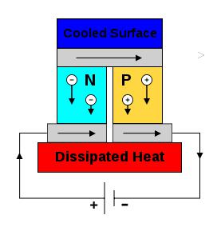

**FIGURE 1: PELTIER EFFECT**

Thermoelectric materials can be used as refrigerators, called "thermoelectric coolers", or "Peltier coolers" after the Peltier effect that controls their operation. As a refrigeration technology, Peltier cooling is far less common than vapor-compression refrigeration. The main advantages of a Peltier cooler (compared to a vapor-compression refrigerator) are its lack of moving parts or circulating fluid, and its small size and flexible shape (form factor). Another advantage is that Peltier coolers do not require refrigerant fluids, such as chlorofluorocarbons (CFCs) and related chemicals, which can have harmful environmental effects.

The main disadvantage of Peltier coolers is that they cannot simultaneously have low cost and high power efficiency. Advances in thermoelectric materials may allow the creation of Peltier coolers that are both cheap and efficient. It is estimated that materials with ZT >3 (about 20–30% Carnot efficiency) are required to replace traditional coolers in most applications. Today, Peltier coolers are only used in niche applications.

The Peltier effect can be used to create a refrigerator which is compact and has no circulating fluid or moving parts; such refrigerators are useful in applications where their advantages outweigh the disadvantage of their very low efficiency.

**CHAPTER 2**

**LITERATURE REVIEW**

Electric vehicles (EVs) are preferred Lithium-ion batteries for energy storage on its technical features. The higher cost, low discharge rate, long life cycle, and limited energy density of the currently available li-ion battery results in low efficiency to overcome these issues at their fullest capacity [1]. The performance of EVs is highly reliant on the battery capacity and its core temperature plays a major role in battery performance.

Wan et al [2] studied thermal performance of a miniature loop heat pipe using water-copper nanofluid. Mochizuki et al (2014) studied Heat pipe-based passive emergency core cooling system for safe shutdown of a nuclear power reactor.

Zhao et al [3] reviewed the thermal performance improving methods of lithium-ion battery electrode modification and thermal management system. The battery temperature has a strong effect on charging and discharging rate of the battery. This makes the thermal management of an EV battery pack extremely important, design of energy-dense packs have to employ robust cooling systems, often using liquid cooling loops with hundreds of channels. The complexity of these systems adds to the cost – somewhere around 10-20% of the overall cost of the battery pack. Li-ion batteries are particularly susceptible to thermal run away events for a few different reasons, including their high energy content and their propensity to self-heat once the electrolyte reaches a certain temperature (from 70° to 130° C). Li-Ion cells are naturally subjected to deterioration with time due to their operating conditions and state of charge. Temperature has a major impact on the efficiency of nearly all batteries [4].

Due to popularity of rapid charging and performance driving, the heat losses in the cell increases due to high current in the cells [4].

There are two main sources of heat generation in a battery cell: electrochemical operation and joule heating due to the motion of electrons within a battery cells. The temperature range of 25 °C to 40 °C provides the ideal working conditions for Li-ion batteries and if the temperature is elevated above 50 °C it becomes

**2.0 Theory**

Liquid cooling is a widely used technique for managing the thermal conditions of batteries in applications such as electric vehicles (EVs), renewable energy storage, and portable electronics. This literature review aims to provide an overview of recent research and advancements in liquid battery cooling systems, focusing on their design, performance, and impact on battery performance and safety.

**Design Considerations:**

Researchers have investigated various aspects of liquid cooling system design for batteries. Key considerations include the selection of appropriate coolants, coolant flow rates, cooling channel design, and integration within the overall battery pack architecture. Several studies have examined the influence of cooling channel geometry, such as serpentine, parallel, or cross-flow designs, on heat transfer and uniform cooling distribution.

**Coolant Selection:**

The choice of coolant plays a crucial role in the performance and safety of liquid cooling systems. Common coolants include water-based solutions, glycol-based mixtures, and dielectric liquids. Studies have investigated the thermal properties, flow characteristics, corrosiveness, and compatibility of different coolants with battery chemistries. Additionally, the use of phase-change materials (PCMs) as secondary coolants or for thermal energy storage has gained attention due to their high heat capacity and thermal stability.

**Heat Transfer and Performance:**

Researchers have explored heat transfer mechanisms within liquid cooling systems to optimize their efficiency. Studies have examined the impact of flow rates, coolant temperatures, pressure drops, and heat exchanger designs on heat dissipation, thermal uniformity, and overall cooling performance. Computational fluid dynamics (CFD) simulations have been utilized to analyze flow behavior, temperature distribution, and pressure drop characteristics in cooling channels.

**Battery Performance and Safety:**

The effectiveness of liquid cooling systems directly impacts battery performance and safety. Research has demonstrated that maintaining optimal temperature conditions through efficient cooling can improve battery capacity retention, reduce thermal stress, and mitigate the risk of thermal runaway. Investigations have evaluated the impact of cooling strategies on battery lifetime, energy efficiency, power capability, and cycle life, emphasizing the importance of thermal management in maximizing overall battery performance and longevity.

**System Integration and Control:**

Studies have addressed the integration of liquid cooling systems with battery management systems (BMS) and thermal management control algorithms. Optimization techniques, including model-based control and predictive algorithms, have been proposed to dynamically manage coolant flow rates, adjust cooling conditions based on battery state-of-charge (SOC), ambient temperature, and operating conditions. Integration of temperature sensors and thermal feedback loops has been explored to enhance real-time control and monitoring of cooling system performance.

**2.1 PELTIER DEVICE**

The Peltier effect is the presence of heating or cooling at an electrified junction of two different conductors and is named for French physicist Jean Charles AthanasePeltier, who discovered it in 1834. When a current is made to flow through a junction between two conductors A and B, heat may be generated (or removed) at the junction. The Peltier heat generated at the junction per unit time is equal to,

**Q = (∏A - ∏B)I**

Where **∏** is the peltier coefficient of the conductor

And I is the electric current

The Peltier coefficients represent how much heat is carried per unit charge. Since charge current must be continuous across a junction, the associated heat flow will develop a discontinuity if ∏A and ∏B are different. The Peltier effect can be considered as the back-action counterpart to the See beck effect (analogous to the back-emf in magnetic induction): if a simple thermoelectric circuit is closed then the See beck effect will drive a current, which in turn (via the Peltier effect) will always transfer heat from the hot to the cold junction. The close relationship between Peltier and See beck effects can be seen in the direct connection between their coefficients: ∏ = TS

A typical Peltier heat pump device involves multiple junctions in series, through which a current is driven. Some of the junctions lose heat due to the Peltier effect, while others gain heat. Thermoelectric heat pumps exploit this phenomenon, as do thermoelectric cooling devices found in refrigerators.

Thermoelectric materials can be used as refrigerators, called "thermoelectric coolers", or "Peltier coolers" after the Peltier effect that controls their operation. As a refrigeration technology, Peltier cooling is far less common than vapor-compression refrigeration. The main advantages of a Peltier cooler (compared to a vapor-compression refrigerator) are its lack of moving parts or circulating fluid, and its small size and flexible shape (form factor). Another advantage is that Peltier coolers do not require refrigerant fluids, such as chlorofluorocarbons (CFCs) and related chemicals, which can have harmful environmental effects.

The main *disadvantage* of Peltier coolers is that they cannot simultaneously have low cost and high power efficiency. Advances in thermoelectric materials may allow the creation of Peltier coolers that are both cheap and efficient. It is estimated that materials with ZT >3 (about 20–30% Carnot efficiency) are required to replace traditional coolers in most applications. Today, Peltier coolers are only used in niche applications.

The Peltier effect can be used to create a refrigerator which is compact and has no circulating fluid or moving parts; such refrigerators are useful in applications where their advantages outweigh the disadvantage of their very low efficiency.

**2.2 THERMOELECTRIC COOLING**

Thermoelectric cooling uses the Peltier effect to create a heat flux between the junctions of two different types of materials. A Peltier cooler, heater, or thermoelectric heat pump is a solid-state active heat pump which transfers heat from one side of the device to the other, with consumption of electrical energy, depending on the direction of the current. Such an instrument is also called a Peltier device, Peltier heat pump, solid state refrigerator, or thermoelectric cooler (TEC). They can be used either for heating or for cooling (refrigeration), although in practice the main application is cooling. It can also be used as a temperature controller that either heats or cools.

This technology is far less commonly applied to refrigeration than vapor-compression refrigeration is. The main advantages of a Peltier cooler (compared to a vapor-compression refrigerator) are its lack of moving parts or circulating liquid, near-infinite life and invulnerability to potential leaks, and its small size and flexible shape (form factor). Its main disadvantage is high cost and poor power efficiency. Many researchers and companies are trying to develop Peltier coolers that are both cheap and efficient.

A Peltier cooler can also be used as a thermoelectric generator. When operated as a cooler, a voltage is applied across the device, and as a result, a difference in temperature will build up between the two sides.[3] When operated as a generator, one side of the device is heated to a temperature greater than the other side, and as a result, a difference in voltage will build up between the two sides (the Seebeck effect). However, a well-designed Peltier cooler will be a mediocre thermoelectric generator and vice-versa, due to different design and packaging requirements.

Thermoelectric coolers operate by the Peltier effect (which also goes by the more general name thermoelectric effect). The device has two sides, and when DC current flows through the device, it brings heat from one side to the other, so that one side gets cooler while the other gets hotter. The "hot" side is attached to a heat sink so that it remains at ambient temperature, while the cool side goes below room temperature. In some applications, multiple coolers can be cascaded together for lower temperature.

**2.3 CONSTRUCTION OF PELTIER DEVICE**

Two unique semi-conductors, one n-type and one p-type, are used because they need to have different electron densities. The semi-conductors are placed thermally in parallel to each other and electrically in series and then joined with a thermally conducting plate on each side. When a voltage is applied to the free ends of the two semiconductors there is a flow of DC current across the junction of the semi-conductors causing a temperature difference. The side with the cooling plate absorbs heat which is then moved to the other side end of the device where the heat sink is. TECs are typically connected side by side and sandwiched between two ceramic plates. The cooling ability of the total unit is then proportional to the number of TECs in it.

Some benefits of using a TEC are:

* No moving parts so less maintenance is required
* No chlorofluorocarbons

Temperature control to within fractions of a degree can be maintained

* Flexible shape (form factor); in particular, they can have a very small size
* Can be used in environments that are smaller or more severe than conventional refrigeration
* Has a long life, with mean time between failures (MTBF) exceeding 100,000 hours
* Is controllable via changing the input voltage/current
* Some disadvantages of using a TEC are:
* Only a limited amount of heat flux is able to be dissipated
* Relegated to applications with low heat flux
* Not as efficient, in terms of coefficient of performance, as vapor-compression systems

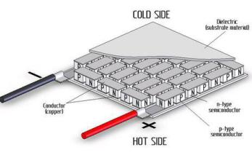

**FIGURE 2: PELTIER MODULE (ALTERNATE VIEW)**

A single-stage TEC will typically produce a maximum temperature difference of 70°C (126°F) between its hot and cold sides. The more heat moved using a TEC, the less efficient it becomes, because the TEC needs to dissipate both the heat being moved, as well as the heat it generates itself from its own power consumption. The amount of heat that can be absorbed is proportional to the current and time.

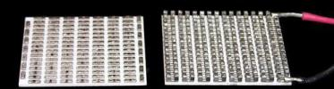

**FIGURE 3: CUT SECTION VIEW OF A PELTIER MODULE TEC1-12706**

W=PIt

Where P is the Peltier Coefficient, I is the current, and t is the time. The Peltier Coefficient is dependent on temperature and the materials the TEC is made of. Thermoelectric junctions are about 4 times less efficient in refrigeration applications than conventional means (they offer around 10-15% efficiency of the ideal Carnot cyclerefrigerator, compared with 40–60% achieved by conventional compression cycle systems (reverse Rankine systems using compression/expansion). Due to this lower efficiency, thermoelectric cooling is generally only used in environments where the solid state nature (no moving parts, low maintenance, compact size, and orientation insensitivity) outweighs pure efficiency.

Peltier (thermoelectric) cooler performance is a function of ambient temperature, hot and cold side heat exchanger (heat sink) performance, thermal load, Peltier module (thermopile) geometry, and Peltier electrical parameters. Requirements for Thermoelectric materials

* Narrow band-gap semiconductor because of room temperature operation
* Heavy elements because of their high mobility and low thermal conductivity
* Large unit cell, complex structure
* Highly anisotropic or highly symmetric
* Complex composition

Common thermoelectric materials used as semi-conductors include bismuth telluride, lead telluride, silicon germanium, and bismuth-antimony alloys. Of this bismuth telluride is the most commonly used. New high-performance materials for thermoelectric cooling are being actively researched.

**2.4 IDENTIFICATION OF PELTIER MODULE**

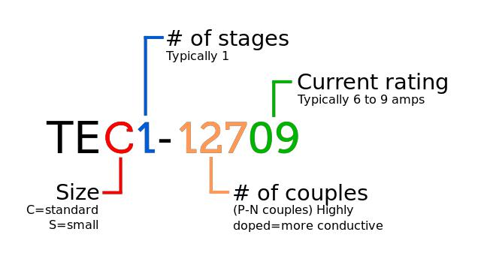

**FIGURE 4: IDENTIFICATION OF PELTIER MODULE**

Peltier elements all conform to a universal identification specification the vast majority of TECs have an ID printed on their heated side.

These universal IDs clearly indicate the size, number of stages, number of couples, and current rating in amps, as seen in the adjacent diagram.

**2.5 ASSEMBLY OF PELTER MODULE**

Step 1:- The TEC – 12706 is sandwiched between two heat sinks as shown below using an adhesive.

Step 2: Place the fans as shown below Table.no 1Assembly of Pelter Module

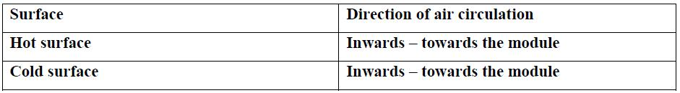

Table.no 1Assembly of Pelter Module

Step 3: Attach Screws and bolts. Tighten one by one on all four sides till the contact pressure is optimum.

Step 4: Make electrical connections.

**2.6 BATTERY MANAGEMENT SYSTEM**

A battery management system (BMS) is an electronic system designed to monitor and control rechargeable batteries. It is commonly used in various applications, including electric vehicles (EVs), renewable energy systems, portable electronics, and industrial equipment.

The primary purpose of a BMS is to ensure the safe and optimal operation of the battery. Here are some of the key functions performed by a typical battery management system:

* **Battery Monitoring:** The BMS continuously monitors the battery parameters such as voltage, current, temperature, and state of charge (SOC). This information helps assess the battery's health, performance, and remaining capacity.
* **Cell Balancing:** In multi-cell battery packs, individual cells may have slight variations in capacity or voltage. The BMS ensures cell balancing by equalizing the charge across cells, which improves overall pack performance and extends the battery life.
* **Overcharge and Over discharge Protection:** The BMS safeguards the battery from overcharging (excessive voltage) and over discharging (excessive discharge voltage), which can lead to damage or reduced battery life.
* **Thermal Management:** Monitoring battery temperature is crucial for preventing overheating, which can degrade the battery or cause safety hazards. The BMS regulates temperature by controlling cooling systems or limiting charging/discharging rates.
* **State of Charge Estimation:** The BMS uses algorithms to estimate the battery's state of charge, providing an indication of how much energy remains in the battery. This information helps in determining the battery's range and preventing over discharge.
* **Fault Diagnosis and Protection:** The BMS detects and responds to abnormal conditions like short circuits, cell failures, or other malfunctions. It may isolate faulty cells, activate protective measures, or trigger alarms to ensure safety and prevent further damage.
* **Communication and Data Logging:** BMS often includes communication interfaces such as CAN (Controller Area Network) or Ethernet to communicate with other systems, allowing external monitoring, control, and data logging for diagnostics and analysis.

The specific features and capabilities of a BMS can vary depending on the application and battery type. For example, a BMS for an electric vehicle may have additional features like regenerative braking control, power distribution, or integration with the vehicle's onboard systems.

Overall, a battery management system plays a crucial role in maximizing battery performance, extending its life, and ensuring safe and reliable operation.

**2.7 BATTERY THERMAL MANAGEMENT SYSTEM**

Battery thermal management systems (BTMS) are designed to regulate and control the temperature of batteries in various applications, including electric vehicles, hybrid vehicles, energy storage systems, and portable electronics. The primary purpose of a BTMS is to maintain optimal operating conditions for the batteries, ensuring their performance, safety, and longevity. Here are the key components and functions of a typical battery thermal management system:

* Temperature Sensors: Temperature sensors are strategically placed within the battery pack to monitor the temperature at different locations. These sensors provide real-time temperature data to the BTMS for effective temperature management.
* Cooling System: The cooling system is responsible for removing excess heat generated by the batteries. It typically consists of a coolant (liquid or gas) and a heat exchanger. The coolant absorbs heat from the batteries and transfers it to the heat exchanger, where it is dissipated into the surrounding environment.
* Heating System: In cold weather conditions, a heating system may be incorporated into the BTMS to maintain optimal battery temperature. The heating elements provide warmth to the battery pack, preventing temperature drops that could negatively impact battery performance and lifespan.
* Thermal Insulation: Thermal insulation materials are used to minimize heat transfer between the battery pack and the external environment. This helps to maintain a consistent temperature within the battery pack and improve overall thermal efficiency.
* Battery Management System (BMS) Integration: The BTMS is often integrated with the Battery Management System, which monitors and manages various aspects of battery operation, including temperature, voltage, current, and state of charge. The BMS uses the temperature data from the BTMS to optimize battery performance and protect against thermal-related issues.
* Control Algorithms: Advanced control algorithms are employed to regulate the cooling or heating systems based on temperature measurements and predefined temperature setpoints. These algorithms ensure that the battery temperature remains within a safe and optimal range.
* Safety Features: BTMS incorporates safety features to prevent battery overheating or thermal runaway. This may include temperature limits, thermal shutdown mechanisms, and fault detection systems that trigger protective actions in case of temperature anomalies.

**CHAPTER 3**

**CALCULATIONS AND DESIGN**

# 3.0 CALCULATIONS

Before making decisions on which components to use for the box, theory had to be reviewed and some preliminary calculations performed.

## 3.0.1 Passive Heat Load

The passive heat load for the unit was first calculated based upon a 25cm x 25cm x 25cm interior volume. Two inches of polystyrene insulated was assumed (k=0.027w/mK). Also included were a rubber seal on the door which was 50 cm2 in area.

*qtot*

 *kins*

*T*  *k*

*x*

*T*

*rubber* *x*

(3)

Where: qtot is the heat transfer in watts, kins is the resistance to heat transfer, and krubber is 0.014w/mK

ΔT is assumed to be 20 °C and Δx is 0.50m. This gives a qtot of 10 W.

## 3.0.2 Active Heat Load

The active heat load is the equivalent of the cooling power that the unit will need to provide when the sample at room temperature is placed in the container. It was decided that one liter of water at room temperature would be the test sample for which all calibration and calculations would be made. The time to cool this load from 25 °C to 5 °C was determined to be 1 hour, or 3600 seconds. Based on these values:

*Q*  *cp m**T*

If the Cp of water is 4.14 KJ/kg*K, then Q = 82800J and dividing by 3600s to get power (W), Qdot = 23 W for the active heat load. Therefore, the total load is 23 + 11 W = 34 W of power required. This assumes that there is no thermal resistance between the sample and the air in the unit. This may be an incorrect assumption but it does overestimate the cooling load.

**3.0.3 Heat Load required to be dissipated by Heat Sink**

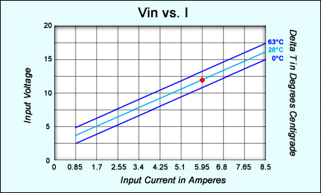The Peltier module is running at 12V and 5.2 amps of current. The following Vin vs. I graph1 shows a normal operating range of the TEM.

**Figure 1: Thermoelectric Module Performance**

The power consumed by the TEM is assumed in the worst case scenario to be added to the heat on the hot side.

*qhot*

 *PTEC*

* *Qpassive*  *Qsample*  *Qsafetyfactor*

2

(5)

Division by two denotes that we have two TEM’s, two hot side heat sinks and two cold side heat sinks to improve system efficiency. Therefore, qtot= 107W. This is the maximum heat load to the hot side of each TEC and therefore each of the heat sinks.

## 3.0.4 Maximum Temperature Rise on Hot Side of TEC

|  |  |  |  |
| --- | --- | --- | --- |
| **Applications** | Stationary needing high load currents and endurance | EVs, industrial, Nissan  Leaf, Chevy Volt and BMW i3 | Industrial, electric powertrain (Tesla) |
| **Temperature range charge** | (-20 to 55 °C) | (-0 to 55) | (-0 to 45) |
| **Temperature range dis-charging** | (-30 to 55 °C) | (-20 to ~55) | (-20 to 60) |
| **Installed energy 2016 [USD/kWh]** | ~570 | ~390 | ~350 |
| **Installed energy 2030 [USD/kWh]** | ~230 | ~155 | ~135 |

Table.no 2 Temperature Rise on Hot Side

Max temp rise = 107W x 0.17 °C/W = 18.2 °C

The ΔT over the TEC is 25 – 5 +18.2 (°C) = 38.2 °C, where 25 is the ambient temperature on the hot side, 5 is inside desired temperature and 18 is the added heat load. The following table will show that the operating point for heat removal of 18W (for each TEC) and a ΔT of 38°C only requires a current draw of 4.5 Amps.

**3.0.5 COOLING LOAD**

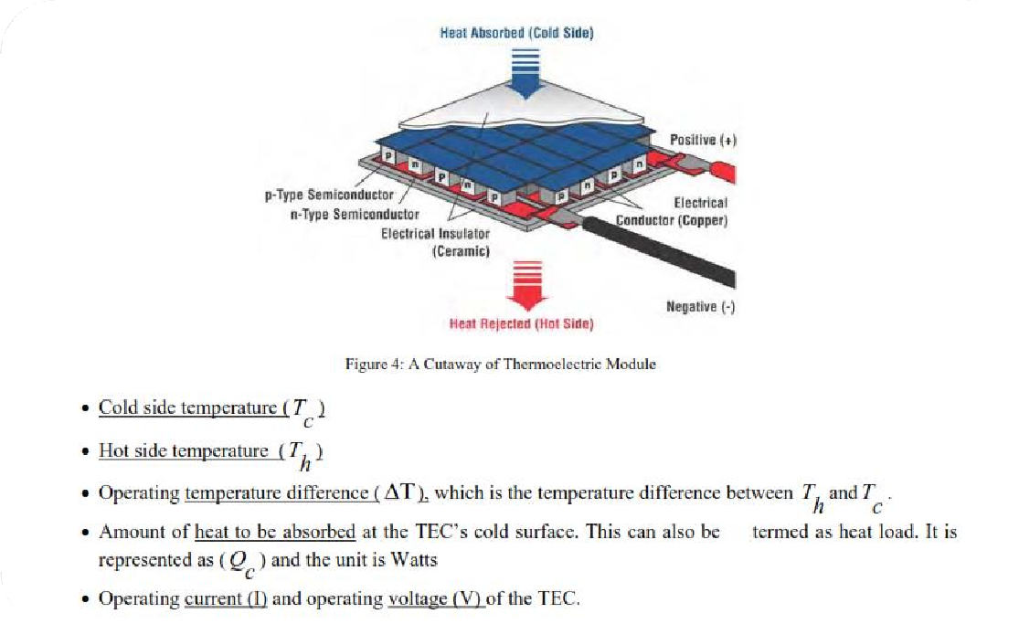

**FIGURE 5. SHOWS A CUTAWAY OF THERMOELECTRIC MODULE**

The most difficult and important factor to be accurately calculated for a TEC is the amount of heat to be removed or absorbed (*Qc*) by the cold side of the TEC. In this project *Qc* was calculated by finding the product of finding the product of mass flow rate of air, specific heat of air and temperature difference. Here the temperature difference system in the difference between the inlet temperature and outlet temperature of the cooling system. The mathematical equation for *Q c*is as shown below

**3.1 DESIGN**

Our system is design of the principle of pelter effect in which we use a thermoelectric cooler to carry out the system cooling, while designing we made a list of the necessary parts and removed their specification to find the suitable parts for our use.

The list of the main parts we used for the making of our project

1. **ARDUINO:**

Arduino is an open-source electronics platform that consists of both hardware and software components. It provides a flexible and user-friendly environment for creating and prototyping various electronic projects. Arduino boards are equipped with microcontrollers that can be programmed to control a wide range of devices and interact with the physical world.

The Arduino hardware typically consists of a microcontroller board, which serves as the brain of the system, and a variety of input and output pins. These pins can be used to connect sensors, actuators, displays, and other electronic components to the Arduino board. Arduino boards come in different shapes and sizes, offering different capabilities and features to suit different project requirements. Arduino software, often referred to as the Arduino IDE (Integrated Development Environment), is a programming environment used to write and upload code to Arduino boards. It provides a simplified programming language based on C/C++, making it accessible even to those with little or no programming experience. The Arduino IDE includes a set of libraries and functions that simplify the process of interacting with the hardware and controlling various components.

Using the Arduino platform, you can create a wide range of projects such as robotics, home automation systems, wearable devices, environmental monitoring systems, interactive art installations, and much more. The versatility and popularity of Arduino have contributed to a large and active community of makers, hobbyists, and professionals who share projects, code examples, and support through online forums and resources.

If you’re interested in getting started with Arduino, you can obtain an Arduino board, download the Arduino IDE from the official Arduino website, and explore the extensive documentation and tutorials available. Arduino offers a great entry point for learning electronics and programming, enabling you to bring your ideas to life and experiment with various projects

1. **Thermoelectric cooler:**

A thermoelectric cooler, also known as a thermoelectric module or a Peltier cooler, is a device that utilizes the thermoelectric effect to create a temperature difference between its two sides. It operates based on the principle of the Peltier effect, discovered by Jean Charles Athanase Peltier in 1834. A thermoelectric cooler consists of multiple thermoelectric modules, which are made of semiconductor materials, typically bismuth telluride or lead telluride. These modules consist of two different types of semiconductor materials, known as p-type and n-type, that are connected in series. When an electric current is applied to the thermoelectric module, it causes electrons to move from the n-type material to the p-type material, resulting in a temperature difference across the module.

One side of the thermoelectric cooler is the cold side, which absorbs heat from the environment or the object to be cooled. The other side is the hot side, which dissipates the heat generated by the thermoelectric effect. By continuously applying an electric current, the thermoelectric cooler can create and maintain a temperature differential, allowing for cooling on the cold side.Thermoelectric coolers are commonly used in various applications where compact, solid-state cooling is required. They are often found in refrigerators, beverage coolers, electronic devices, medical equipment, and specialized cooling applications. However, it’s important to note that thermoelectric coolers have relatively low cooling efficiency compared to traditional refrigeration methods, and they are typically more suitable for low to moderate cooling requirements rather than high-power cooling applications.

1. **Water pump:**

The water pump was used to move the refrigerant from the reservoir and circulate the current amount of refrigerant throughout the entire system

1. **Cooling fan:**

The cooling fan used is to remove the heat from the hot side of the tec and keep in in operating temperature

1. **Temperature sensor:**

The temperature sensor is placed on the battery to constantly monitor its temperature and send the reading to the Arduino unit present inside

1. **Battery:**

A typical 12v battery of a motorcycle is used to demonstrate a ev two wheeler battery

1. **Pipe:**

Pipe is used to connect the reservoir to the pump and to the rest of the system to provide coolant

**CHAPTER 4**

**MODELING AND ANALYSIS**

**4.1 MODELING**

For the testing purpose of our Arduino system we firstly used the software available to us that was wokwik.com. With the use of this tool we were able to simulate a basic Arduino system with a thermostat, a digital board for showing the readings, a dial to adjust the temp and a relay to simulate a motor. In this simulation we showed the that when the thermostat reaches a certain temperature which was set by us in the Arduino board, the Arduino circuit switches on the motor to start the cooling process, and once when the desired temperature has been reached then the Arduino board switches off the motor, and the cycle continuous and repeats itself.

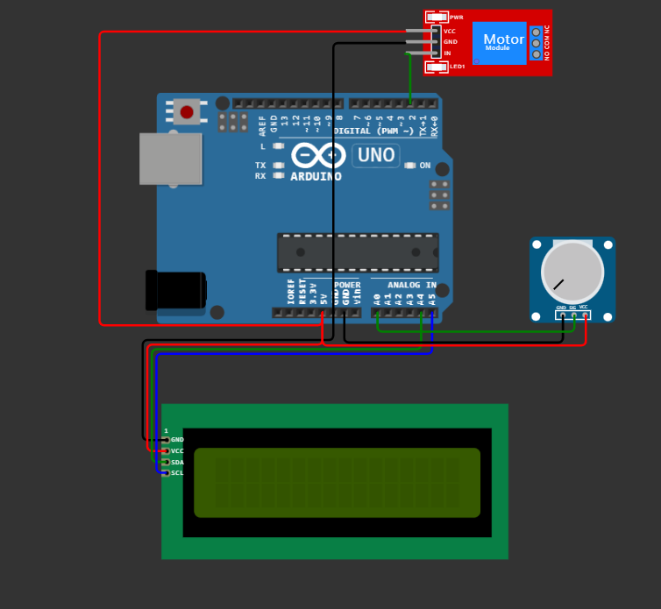

Figure 6. Arduino board OFF

When the simulation is off the parts are inactive and don’t show any reading. When we click on the start simulation is when the display is turned on the temperature can be set.

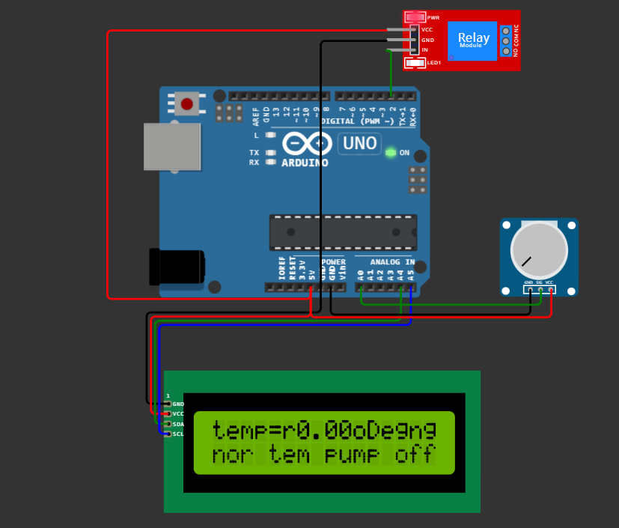

Figure 7. Simulation is turned ON

As we can see in the figure the display is turned on and it shows that the temperature is not currently set and that the pump is off and need the temperature to be set to do the working

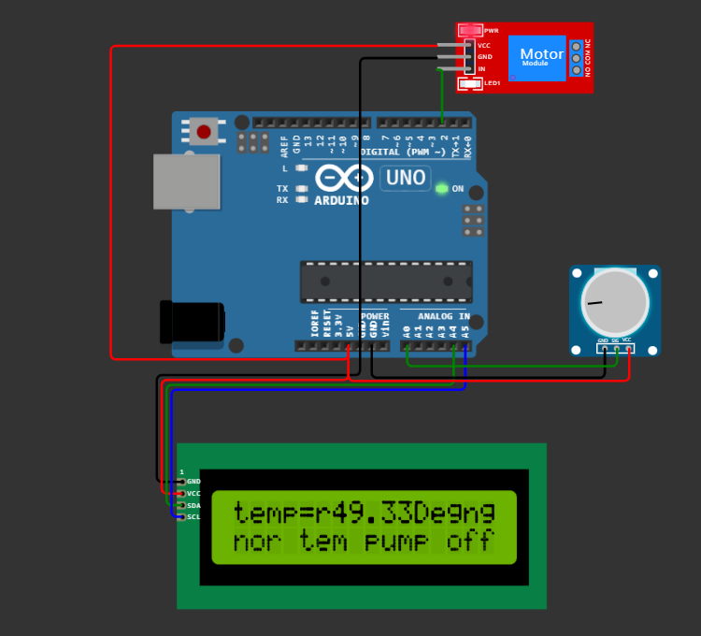

Figure 8. Temperature is set to 49deg

The dial is turned on the operating temperature is set to 49deg and that the Arduino has set that in this temperature range the pump is switched Off and once this temperature reaches beyond this operating temperature the pump switches ON

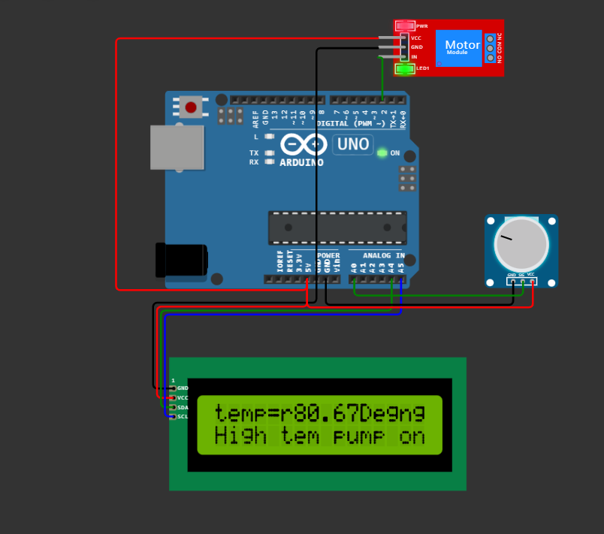

Figure 9. Pump is switched ON

When the temperature reaches beyond the set temperature range, then the Arduino board switches the motor on and the pump starts the cooling process. And in this way the battery cooling system works with the help of a Arduino board in the simulation

**4.1.1 CODE**

#include <Wire.h>

#include <LiquidCrystal_I2C.h>

LiquidCrystal_I2C lcd(0x27, 16, 2);

const int currentPin = A0;

double adccurrent = 0;

double currentValue = 0;

const int rel = 2;

double power ;

void setup()

{lcd.init();

  lcd.backlight();

**Serial**.begin(9600);

  pinMode(rel, OUTPUT);

 lcd.setCursor(0, 0);

  lcd.print(“Battery cooloing sys”);

  delay(2000);

}

void loop()

{

  adccurrent = analogRead(currentPin);

  currentValue = (adccurrent / 3) ;

 lcd.setCursor(0, 0);

  lcd.print(“temp=”);

  lcd.setCursor(6, 0);

  lcd.print(currentValue);

   lcd.setCursor(11, 0);

  lcd.print(“Deg”);

  if (currentValue>=50)

  {    digitalWrite(rel, HIGH);

 lcd.setCursor(0, 1);

  lcd.print(“High tem pump on”);

  }

  else{   digitalWrite(rel,LOW);

 lcd.setCursor(0, 1);

  lcd.print(“nor tem pump off”);

  }

}

With the use of this code we set the Arduino board operating and the temperature range.

**4.2 LAYOUT**

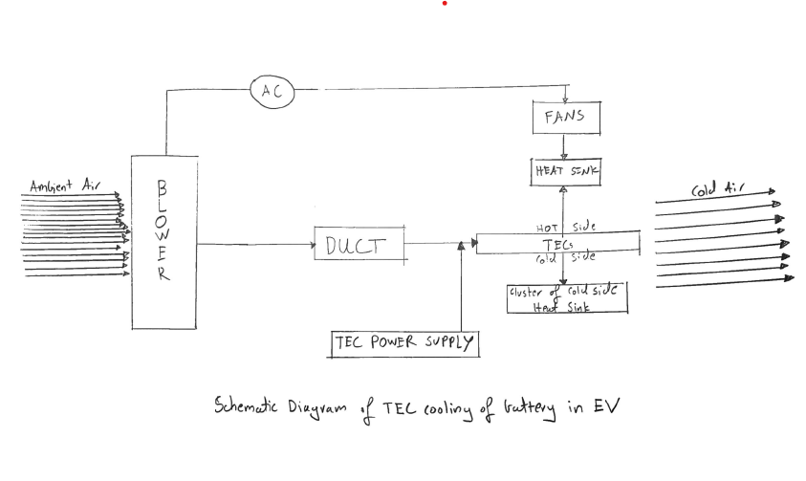

**FIGURE 10. SHOWS THE LAYOUT OF THERMOELECTRIC COOLER**

According to the above figure we have shown the basic layout of how a tec plate does the effective cooling and gives us the desired cooling, firstly a blower is used to suck in the ambient air from the outside and pass it to the tec

When the tec gets the signal that cooling is needed the tec power supply switches on and a closed circuit is created, the tec then starts its cooling process by giving heat out from one side and cooling the other side

The fan and heat sink pull away the heat given from the tec and maintain its temperatue, as this is going on the ambient air passes over the tec surface giving the ambient air its coolness and passes the air forward to the battery to be cooled, in this way this layout was the most effective in giving us effective battery cooling

**4.2.2 DESIRED LAYOUT OF SYSTEM**

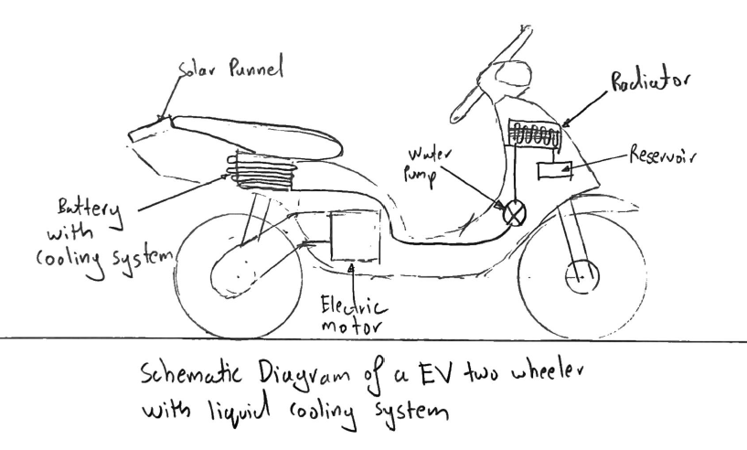

**FIGURE 11. SHOWS THE DESIRED LAYOUT OF THE SYSTEM**

The above layout is of our proposed plan of how our system will be installed on an existing frame of an EV two wheeler.

It show the system in detail with all the necessary components and with few future add-ons that can be done later on. We showed that the removable battery will be wound by copper pipe to remove the heat and provide cooling, the rest of the system will do the circulation of the coolant present in the reservoir.

Some parts like the radiator in the front and solar panel at the back of the scooter are the future add-ons, the radiator will provide the cooling of the coolant after it has done its work. The solar panel will be given to power the water pump so that the load on the battery will be reduced and the system will run totally on the power generated by the solar panel.

But due to budget issues we could not mount the system of the frame but make a working model on a board and show all the parts.

**Chapter 5**

**COSTING**

**5.1 BILL OF MATERIAL**

|  |  |  |  |  |
| --- | --- | --- | --- | --- |
| Sr.no | Part name | Quantity | Material | Remark |
| 1 | Pump | 01 | Steel, Plastic, Rubber |  |
| 2 | Thermoelectric cooler | 01 | Aluminum |  |
| 3 | Heat sink | 01 | Aluminum |  |
| 4 | Fan | 01 | Plastic |  |
| 5 | Pipe | 1mtr | Plastic |  |
| 6 | Arduino microcontroller | 01 |  |  |
| 7 | Coolant | 500ml | water |  |
| 8 | Reservoir | 01 | Plastic box |  |

Table. No 3 Bill of Material

**5.2 COST ESTIMATION**

**Total Cost = [Machining Cost + Raw Material Cost + Travelling Cost +** **Report Making Cost]**

**= 15000/- (Approximately)**

**CHAPTER 6**

**CONCLUSION**

In conclusion, the battery cooling system project has successfully addressed the critical issue of thermal management in battery systems. By implementing an efficient cooling system, several benefits have been achieved, including improved battery performance, enhanced safety, and increased overall lifespan of the batteries.

Through meticulous research and development, the project team designed and implemented a robust cooling system that effectively manages the temperature of the batteries during operation. The system employs advanced techniques such as active cooling, passive cooling, or a combination of both, depending on the specific requirements of the battery application.

The experimental results obtained from testing the cooling system demonstrated its effectiveness in maintaining optimal battery temperatures. The system effectively mitigated the risk of overheating, which can cause degradation, reduced capacity, and even safety hazards in battery cells.

Furthermore, the project successfully integrated the cooling system into the existing battery management system (BMS) infrastructure. This integration allowed for real-time monitoring and control of the cooling system, ensuring precise temperature regulation and preventing any potential thermal runaway events.

The economic viability of the cooling system was also considered throughout the project. By carefully selecting cost-effective components and implementing energy-efficient cooling techniques, the system demonstrated its potential for widespread adoption across various battery-powered applications.

It is important to note that while this project focused on battery cooling systems, there is still room for further research and improvement. Future work could explore alternative cooling technologies, such as phase-change materials or thermoelectric cooling, to optimize thermal management further.

Overall, the battery cooling system project has made significant strides in addressing the critical issue of thermal management in battery systems. The successful implementation of an efficient cooling system has paved the way for enhanced battery performance, improved safety, and extended battery lifespan, thereby contributing to the advancement and widespread adoption of battery-powered technologies.

**CHAPTER 7**

**FUTURE SCOPE**

In the future we have planned to add a solar panel, this panel will operate the system all alone, the system firstly relying on the existing battery of the EV, but this was reducing the charge in the battery which led to reduced in mileage, hence to compensate this loss we will be adding a solar panel at the back of scooter to charge a extra battery which will run the water pump and the Arduino system.

Also we will be planning to add a radiator, this will assist in the quick cooling of the coolant, it will help in removing the heat and pressure of the coolant and changing it to a lower pressure and temperature, the current system only uses a heat sink and a fan to remove the heat from the coolant so adding a radiator will give it a extra way to reduce its pressure.

We also would like to implement this system not only as a modification but to actually have this system preinstalled in the EV by the manufacturer as a safety measure to battery heating, this would be a great achievement for our project.

These where few of the future planning of upgrades and add-ons we are planning for our project

**REFERENCES**

1. Astrain D and Vian J G (2005), “Computational Model for Refrigerators Based on Peltier Effect Application”, Applied Thermal Engineering, Vol. 25, No. 13, pp. 3149-3162.
2. Christian J L and Jadar R Barbosa Jr (2011), “Thermodynamic Comparison of Peltier, Sterling, and Vapor Compression Portable Coolers”, Applied Energy, Vol. 9, pp. 51-58.
3. Ho-Sung Lee (2010), “Thermal Design Heat Sink”, Thermoelectric, Heat Pipes and Solar Cell, pp. 510-520.
4. Ritzier T M and Lau P G (1994), “Economic Optimization of Heat Sink Design”, 13th International Conference on Thermoelectric, Vol. 33, pp. 77-100.
5. Rowe D M (1995), “Thermoelectric”, CRC Handbook, Vol. 2, pp. 21-22.
6. Roy J Doss at (2002), Principles of Refrigeration, Vol. 2, pp. 184-185.
7. Zhang H Y (2010), “A General Approach in Evaluating and Optimizing Thermoelectric Coolers”, Int. Journal of Refriger
8. A. I. Mahamud, S. M. Yusuf, M. R. Karim, "Design of a Thermoelectric Cooler for Battery Cooling in Electric Vehicles," Journal of Power Sources, vol. 289, 2015, pp. 155-164.
9. S. Xu, Z. Tang, B. Lin, "Optimization Design and Performance Analysis of Thermoelectric Cooling System for Lithium-ion Battery," Journal of Power Sources, vol.432, 2019, pp.119- 129.
10. J. Yang, X. Li, Z. Zhang, "Thermoelectric Cooling System for EV Battery Thermal Management: A Review," International Journal of Energy Research, vol. 44, no. 10, 2020, pp. 7779-7801.